**Class Exercise #7 – Logo and Branding**

Instruction

1. Similar instruction to past Class Exercises instructions.

2. Please use MS Windows 10 Snipping Tool to take screen shot of the following Tasks, **screen shot of the web browser not the HTML code from the video, make sure it is legible and readable screen shot.**

2. Please put your full name in the header.

3. Please do not modify this document to another format, keep as MS Word with .docx.

4. Submit this document to eCampus > Submit Your Assignment Here > Class Exercise #7 Submit Here. Refer to the syllabi for due date.

5. In this assignment you will create the following html documents:

* Task A – **logo.html, depends if you use Adobe Photoshop or Illustrator** with **logo.psd** or **logo.ai** source files, respectively, and optimization formats: .svg .jpg, .png or .gif

**NOTE**: The only two formats with transparent background are .png and .gif.

6. In regard to your index.html page, **link the index page to the all webpages in step #5 above**, like you did for Class Exercise #1, 2, 3, etc., and link to and from the index.html to these .html files.

I should not use the back or forward-arrow buttons for navigation.

7. Please place all web pages under the Assignment column in your main index page, provide description to each under the Description column and include the date when you did this, when you link from your index page to these webpages and back to index.html, post your Class Exercise assignment, link it from your index.html page, using FileZilla FTP account information, to your web directory. Please check on the web server to make sure all links are not broken.

8. File Structure – Please organize you file structure appropriately; with only one index.html file at the root of your directory, with several sub directories (022320, 023020, etc.), ClassExercises, ClassProject sub directories, and only one index.html file at this time. Everyone is going to have your own file structure, please be consistent with your naming of file structure.

Like this:

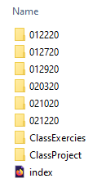

**NOTE:** Every semester is different, different dates, folder names, create sub directories of dates, etc. but put everything inside ClassEx7 sub directory. Everyone’s file structure will vary, but needs to remain consistent.

**NOTE**: Your local directory should mirror the same file structure on the FTP web server.

---------------------------------------------------------------------------------------------------------------------------------------

**How to Design a Logo**

Logo design will be different every time, depending on the brand's overall identity. Each identity project is unique. They all have their own issues to overcome and challenges to conquer. But you should still approach each brief in a similar way: develop a workflow that allows maximum creativity and is productive.

This class exercise will walk you through the core stages of creating a new identity. I'll show you how this identity was conceived, explaining each stage of the process from when the ideas were born through to the final presentation. As well as demonstrating some of the essential tools and skills that you can learn to help streamline your workflow in Illustrator, I'll also share a few best-practice rules of thumbs for working smarter.

Task A is just a case study of how to create a logo from scratch, with pencil and paper, more important is the concept behind this logo creation**. Please do not create the same logo as demonstrate in Task A. You need to create your own logo and branding.**

Here's link to download Adobe Creative Suite:

<http://blog.dcccd.edu/2020/05/download-and-install-your-adobe-creative-cloud-apps/>

I understand some of you never opened Adobe Photoshop or Illustrator, or any graphic software before this course. You are welcome to use Microsoft Pain or any other graphic software to create your logo. You graphic logo can be bitmap (.jpg, .jpeg, png, .gif) or vector (.eps) based.

**NOTE: Please keep you source file, if you use Adobe Photoshop, then the source file is .psd, and if you are using Adobe Illustrator, the source file is .ai. Keep all the layers and do not collapse or remove and filters or mask. If you don’t know what I am talking about, that’s all right.**

---------------------------------------------------------------------------------------------------------------------------------------

**Task A: Logo**

1. **Always start with pencil and paper.**

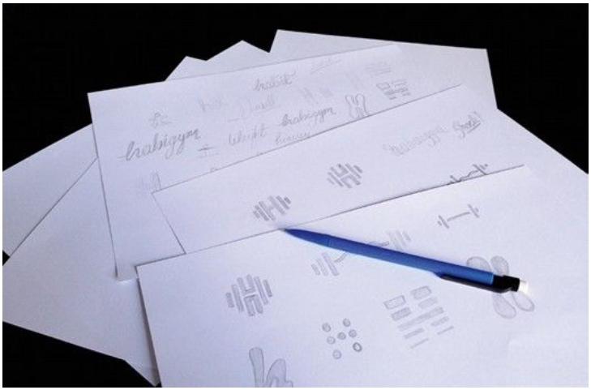

Sketching your concept on paper is an important stage.

I am a programmer, before I program a code, the logic flow has to work on pencil and paper first, if it doesn’t work logically, then the program will not work. Similar to logo design, pencil and paper, allows you to see and touch the texture before the digital format. Your logo should convey a meaning and communicate about your portfolio (Animation, Graphic, Web or Video).

Everyone knows they should start with a plan, but with deadlines looming it's all too easy to forget this stage – don't. A major part of identity design involves solving a problem with a concept. For many, this happens much more fluidly on paper, as your mind bounces off each thing you sketch out.

**2. Mobile scanner**

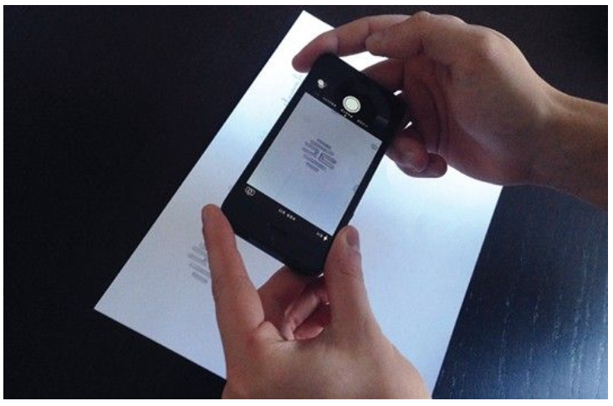

A scanner helps you to be precise, save as .jpeg, and email the image to yourself.

Insert your logo image here:

If you have a scanner, use that for the best results. If you don't have one to hand, take photos of your sketches. You can then use them as guides for digital recreation. When it comes to logos, precision is essential. Therefore, Live Trace needs to be ditched and the work needs to be done manually.

**3. Practice makes perfect**

The Pen is a very powerful tool

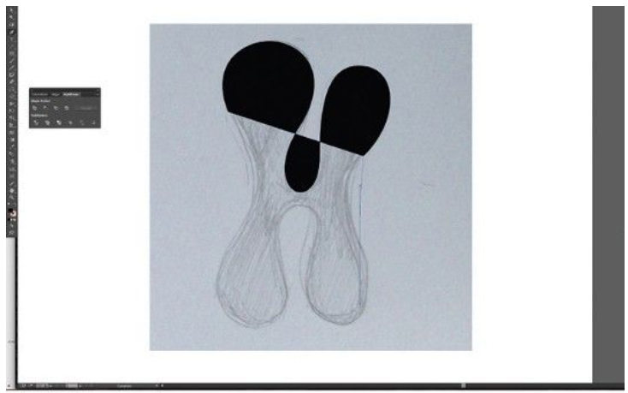

I used Adobe Illustrator for this logo, you are welcome to use Photoshop as well. Because I will save this source file as **.ai** format. In Photoshop, you will need to save it as **.psd** or **.eps** for vector format.

**NOTE:** An SVG file is a graphics file that uses a two-dimensional vector graphic format created by the World Wide Web Consortium (W3C). It describes images using a text format that is based on XML. SVG files are developed as a standard format for displaying vector graphics on the web.

The Pen tool is probably the most frequently used – but remains one of the trickiest to master. It's a very powerful tool and learning it will not only benefit your ability to create images in Illustrator, the skills you acquire will also boost any Photoshop Pen work you do.

If we are on campus, we’ll use the WACOM tablets, or you can check out the WECOM tablet to use in the lab.

Use the Snipping Tool, take screen shot of your logo in either Photoshop or Illustrator, copy/paste below:

**4. Utilise the Shapes panel**

When I was designing the health fitness gym logo, the image in my mind was weights, barbells, benches, etc.

 The look and feel of the logo create a gym branding.

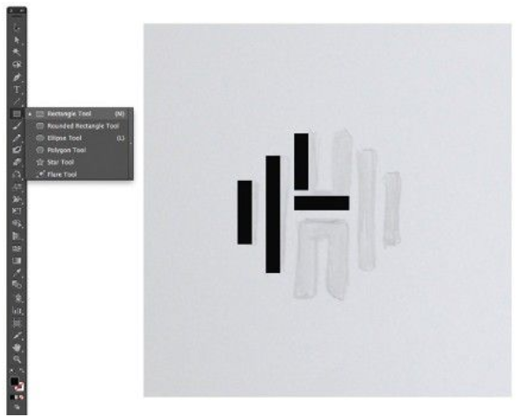

The Shape panel gives better accuracy

Create this logo by combining rectangles using the Rectangle tool. When building the vectors, try using the Shape panel for better accuracy. Hold Shift to draw shapes with equal proportions. Select any element, and its width and height are shown in the Control bar. You can type in sizes here too.

**5. Duplicate elements and combine**

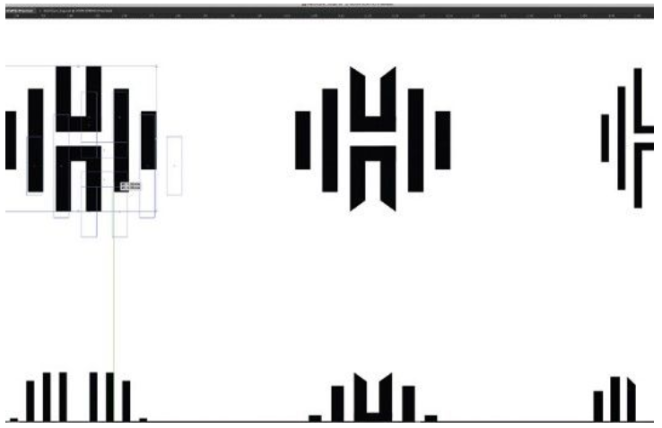

The Pathfinder tool combines shapes and adds new ones

To compare variants, duplicate a master copy to edit (hold Alt and drag). Create shapes to align objects and use Smart Guides (View>Smart Guides). Use the Pathfinder tool to combine shapes and create new ones. You can combine rectangles to make the 'H' element: select both elements and hit Merge.

**6. Tweak the type**

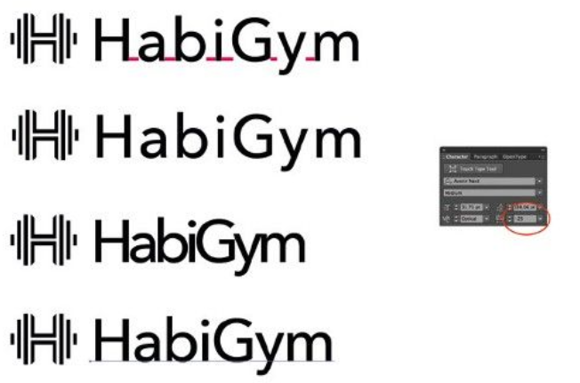

Add fonts, here’s free font website: <https://www.1001freefonts.com/> , you can download compressed file, and uncompressed to your Adobe directory:

For Apple: <https://support.apple.com/en-us/HT201749>

For PC: "Shared" **fonts** across all **Adobe** applications are **stored** on **Windows** in C:\Program Files (x86)\Common Files\**Adobe**

Alter the tracking and kerning of words to change the tone of a logo. Add character to the logotype by opening up the shapes into the native paths that make up the letters, altering the paths of each letter directly to make your type unique. To quickly convert the font to outlines (paths) hit Cmd/Ctrl+Shift O.

**7. Keep changes subtle**



Changes Be careful and stay subtle

Use the Direct Selection tool to rearrange the anchor points and alter the appearance of the letters. Keep changes small and subtle. Careful scaling of the logo mark with the type is crucial to achieve cohesion between the two. Hold Shift to keep everything in proportion as you scale elements up and down.

**8. Time to add colour**

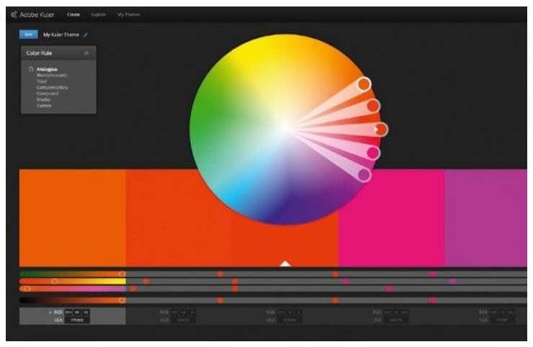

View colour palettes and avoid gradients

**OPTIONAL:** In CS4 and higher, you can integrate Adobe's Kuler app into your workspace to view colour palettes. Go to Window > Extensions > Kuler. Try to avoid gradients in logos, but don't take that as an absolute rule. Hit Cmd/Ctrl+F9 to access the Gradient dialog. Try the logo on a variety of background colours and shapes.

**9. Create delivery templates**

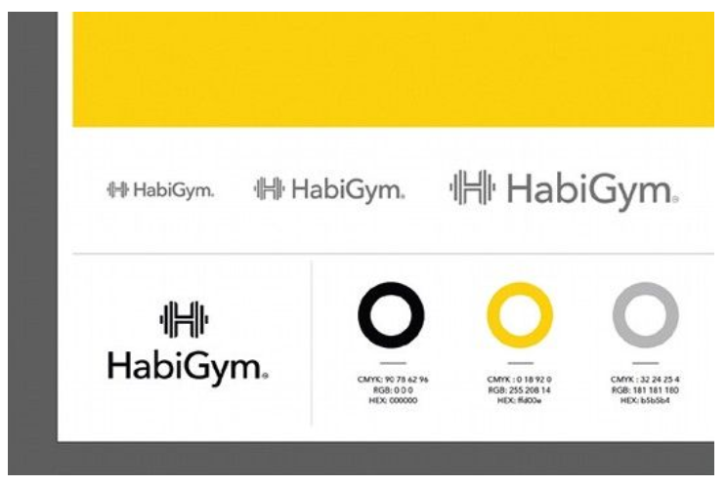

Consider your brand when choosing your fonts

Go to File > Save As > Illustrator Template. Choose fonts that work well with the brand. Create style guides for designs: add CMYK colour breakdowns, Hex codes or Pantone codes, and font names – this is useful for designers and ensures brand consistency.

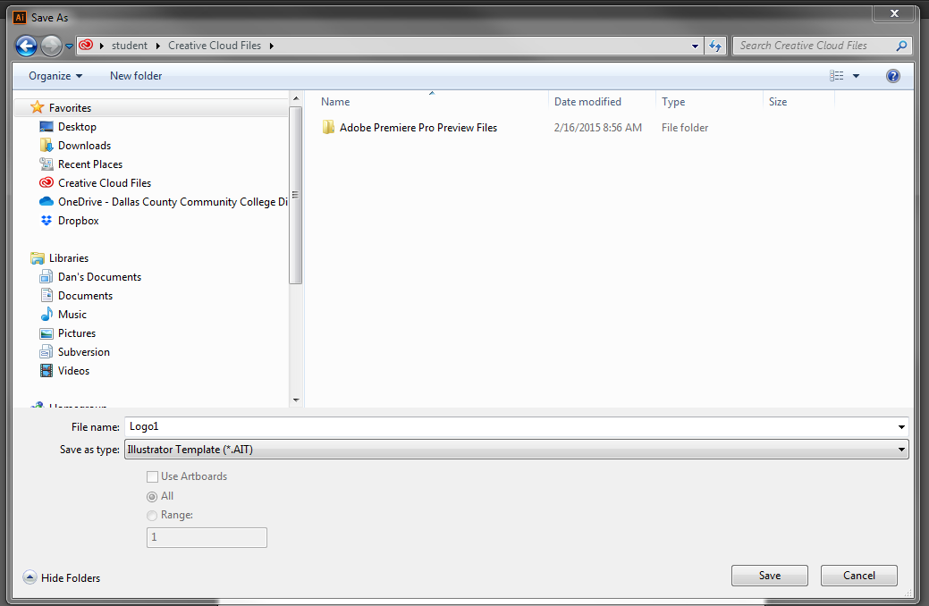

Here’s what I need to be submitted:

1. Create a **logo.html** file and insert the logo with .svg, .png, .jpg, .jpeg, or .gif (one of these format) file in the body.
2. Use the Windows OS Snipping Tool, copy and paste the logo below:

1. Link the **logo.html** to and from your main **index.html** web page. Put your web directory URL to your index.html page below:

https://www.mmlab2.rlc.dcccd.edu/imed1416-83840/web8520/index.html

1. Upload this complete document **AND** the source files (.psd or .ai) to eCampus before due date.